Derek Jarman Protest!
Symposium - 24 March 2022
Call for presentations / papers / interventions
Convened by Jez Dolan – Artist in Residence and the Queer British Art Research Group

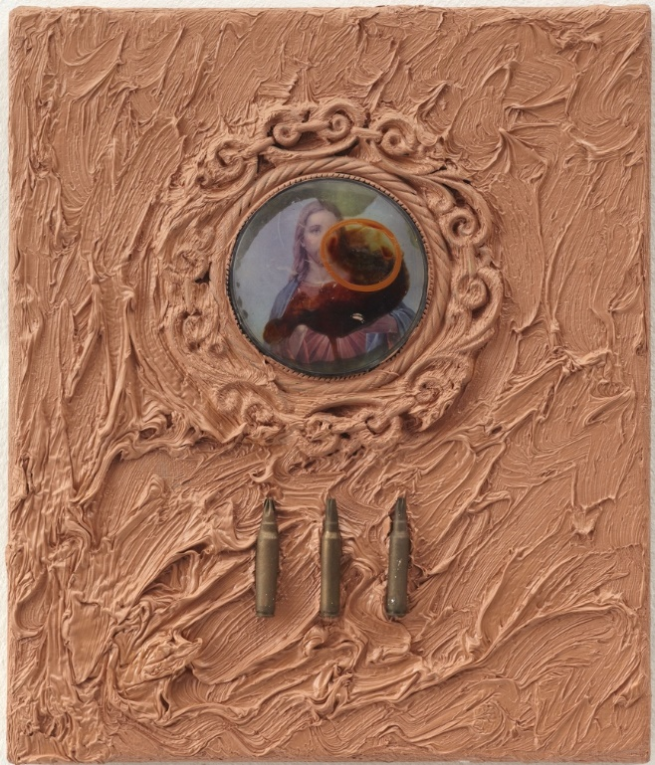
Derek Jarman, Flesh Tint, 1990, oil and mixed media on canvas. Courtesy: Amanda Wilkinson Gallery

Artist Jez Dolan is artist-in-residence at Manchester Art Gallery as part of the exhibition Derek Jarman Protest!, a major retrospective of one of the most influential figures in 20th century British culture.

As part of the residency Jez is collaborating with the Queer British Art Research Group to present a day-long symposium using the exhibition and Jarman’s practice as a leaping-off point for discussion, debate and interventions. The symposium will welcome artists, academics, curators, students, writers and those with a general interest in Jarman’s life, works and legacy.

We are encouraging participation from practitioners from a wide range of backgrounds to submit outlines for presentations in any format. This could include: academic papers, performance or intervention, group discussion, practical workshop sessions and other formats we may not have thought of. We would ask that any presentation be dynamic and that it reflects Jarman’s life, work and legacy in some way

Areas for consideration could include but are not limited to:
- What is Jarman’s legacy to the canon of queer art, and what is his legacy to younger queer artists
- The breadth of Jarman’s process(es)
- Derek Jarman Protest! as a starting point for thinking about exhibition making
- The collaborative nature of Jarman’s practice / collaborative practice more widely/the establishment of a ‘company’ of collaborators
- Art as activism and as a form of protest

This symposium will be a blended event. It will take place at Manchester Art Gallery. For those unable to attend in person, a zoom link will be available to take part in the symposium remotely. It will be monitored for questions and feedback throughout the day. Proposals are encouraged from prospective speakers who wish to contribute both in person and via zoom.

As part of his residency, Jez Dolan will be in the Jarman exhibition every Thursday between 1pm -3pm. If you are unable to attend, you can contact Jez on the email below with any questions.

Send proposals to: jez@jezdolan.com

Schedule:
- Deadline for submissions: 14th February
- Confirmation of participation: 25th February
- Event: 24th March

Proposals should be no longer than one side of A4. Please include relevant weblinks etc. Queer British Art Research Group can offer an honorarium of £200 to each selected speaker whose participation in the event will take part outside of a waged role.

Jez Dolan is an artist and theatre maker based in Manchester. He has shown work and undertaken residencies internationally. His work is in a number of private and public collections including the British Museum, Manchester Art Gallery, the Leslie Lohman Museum NYC, UK Government Art Collection and the Schwules* Museum Berlin

Manchester Art Gallery was initiated in 1823 by artists, as an educational institution to ensure that the city and all its people grow with creativity, imagination, health and productivity. The gallery is free and open to all people as a place of civic thinking and public imagination. It promotes art as a means to achieve social change with its origins from the
Royal Manchester Institution for the Promotion of Literature, Science and the Arts. Through its collections, displays and public programmes it works with all our constituents to ensure creativity, care and consideration infect all aspects of the way we live. This is an art school for everybody and for life.

The Queer British Art Research Group is part of the British Art Network. BAN is a Subject Specialist Network and is supported financially by the Paul Mellon Centre for Studies in British Art and Tate, with additional funding provided by the National Lottery through Arts Council England.

Jez’s residency is funded by Arts Council England and Manchester Art Gallery

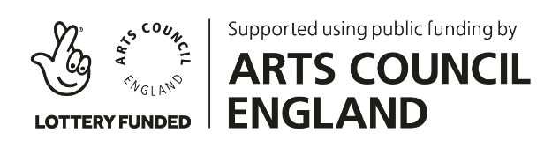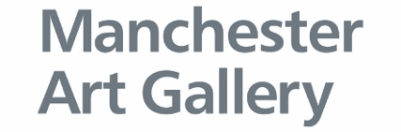

Queer British Art Network receives support and funding from:

