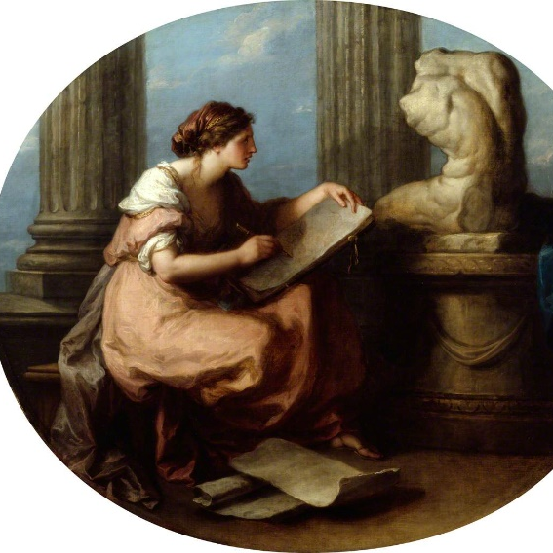
ENLIGHTENED WOMEN: BRITISH WOMEN
ARTISTS IN THE EIGHTEENTH CENTURY
A collaborative curatorial workshop
Friday 9 September 2022
10-5pm
Royal Academy of Arts, Burlington House
Guidelines for Papers
LONDON

CALL FOR PAPERS GUIDELINES

- BACKGROUND
‘Enlightened women: British women artists in the eighteenth century’ is a collaborative curatorial workshop comprising of a keynote address and a series of short form papers in the morning followed by a workshop in the afternoon (with a shared lunch in between). The aim of the workshop is to devise a curatorial rational for a hypothetical exhibition about women and visual culture in Britain during the eighteenth century. As a group, we will agree on our expected outcomes and share our ideas and results at the close of the day. This hypothetical exhibition would draw material from collections in the UK and Australia and an Australian iteration will be held at The Australian National University in October. There is also the opportunity to bring both groups together online in November. It is anticipated that proceedings from the seminar series will be published electronically and that your papers may be included with your permission.

- HOW TO SUBMIT A PAPER PROPOSAL
Please email your submissions by 24 JULY 2022 to the convenor, Lara Nicholls, PhD candidate in the Centre for Art History and Art Theory at The Australian National University, Canberra.
lara.nicholls@anu.edu.au
Short papers in this seminar are limited to 10-15 minutes and should be supported by a PowerPoint on the day of approximately 10-20 slides.
Please submit an abstract of 250 words which includes the following points:
- Author’s name, title, position, and institution/organisation
- Working title of the paper
- 250-word abstract
- 4 key images with captions
- 4 key words

- SOME THEMES TO CONSIDER FOR YOUR PAPER
- Collaboration and the circulation of objects and ideas
- Political activism and proto feminism
- Colonization and gender
- The sister arts of painting, music, and poetry
- Creative spaces and exhibition culture
- The self and power
- Counter hierarchies in handcraft, fancywork, and fibre art
- Travel and movement
- Enlightenment
- The Royal Academy and artist societies
While single topic papers on an artist or a specific work of art are most welcome, we actively seek interdisciplinary papers which have a focus on networks of creative practice and ideas sharing in the eighteenth century. Visual culture in the period is an overarching theme but we are keen to see how this might overlap with social, political, and philosophical concerns regarding gender and society during the Enlightenment.
- THE CONCEPT OF ‘ENLIGHTENED WOMEN’
This collaborative curatorial seminar project explores the life, practice, and creative spaces of British women artists in the eighteenth century. The aim of the seminar is to create a curatorium of interested curators and scholars who meet in a two-part workshop in the UK and Australia. The seminar seeks to reveal new approaches to the art of the period, beyond the mainstay of male portraitists and antiquarians. It is hoped that it will spark new interest in an era in which significant cultural, political, and economic transformation occurred. The mission is to uncover more women artists in this period and discover new or forgotten works; and to devise a curatorial plan for a proposed exhibition of eighteenth-century women artists to be held in Australia and Britain. Despite renewed interest in feminist art history, little attention is given to the work women artists in this period. While scholars of note have made some remarkable contributions in the field, gaps remain. This limits our understanding of women’s creative practice during this period. A stubborn adherence to old stereotypes which identify women as accomplishment, or amateur artists during the Age of Enlightenment seem to persist. However, the archival records suggest otherwise with women appointed as Royal Academicians and consistently exhibiting at the RA, British artist societies, and joining European academies. The nineteenth-century biographer of British Female painters, Ellen Clayton chronicles over twenty women working at the time and lists many works requiring further research and inspection. As she concluded of women artists in the period, ‘The shadows have melted back into the gray (sic) dimness from which they rose – passed as a dream of Fair Women; graceful, noble figures, laden with highest and purest gifts. A golden circlet of stars, the like of which no other land could show.’ This transnational proposal aims to connect curators and institutions around the globe, linking collections and making new relationships.

Remember to follow us on Facebook for regular updates
https://www.facebook.com/britishwomenartistsinthe18thcentury

We look forward to welcoming you to our seminar series in London on Friday 9th September!
Yours sincerely,
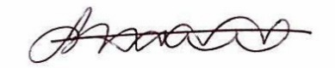
Lara Nicholls
PhD Candidate and Jennifer Strauss Fellow in the Humanities
Centre for Art History and Art Theory
The Australian National University

